REPORT ARCHIVING SYSTEM FOR BFP MATALAM

SEAN ERNEST P. AGUDA

BACHELOR OF SCIENCE AND INFORMATION SYSTEMS



DECEMBER 2025

REPORT ARCHIVING SYSTEM FOR BFP MATALAM

SEAN ERNEST P. AGUDA

Capstone Project Manuscript Submitted to the Department of Computing and Library Information Science, College of Engineering and Information Technology, University of Southern Mindanao,
Kabacan, Cotabato in Partial Fulfillment of
The Requirements for the Degree of

BACHELOR OF SCIENCE IN INFORMATION SYSTEMS



DECEMBER 2025



UNIVERSITY OF SOUTHERN MINDANAO
Kabacan, Cotabato
Philippines

APPROVAL OF THESIS MANUSCRIPT

Name | SEAN ERNEST P. AGUDA
Major | N/A
Degree Sought | BACHELOR OF SCIENCE IN INFORMATION SYSTEMS
Specialization | N/A
Thesis Title | REPORT ARCHIVING SYSTEM FOR BFP MATALAM

APPROVED BY THE GUIDANCE COMMITTEE

______JOSEPH C. LORILLA_____ ______________________________
Adviser Co-Adviser
(Optional)

______________ _____________
Date Date

____________________________ _____CATHERINE C. DAFFON____
Statistician Department Research Coordinator (Optional)

______________ _____________
Date Date
JANICE T. PALMAERA
Department Chairperson

______________
Date

SHIERYL P. ORTIZA MARICEL G. DAYADAY
College Research Coordinator Dean

______________________ ______________________
Date Date

Study No: BSIS 2024_40
Index No:MC-CEIT-013242
Recorded by: _____________
RECORDED:

LYDIA C. PASCUAL
Director for Research and Development Office

_________________
Date
Recorded by: __________
USM-EDR-F05-Rev.4.2020.11.16
ii


College Seal
UNIVERSITY OF SOUTHERN MINDANAO
Kabacan, Cotabato
Philippines
ACCEPTANCE OF THESIS

The thesis attached hereto, entitled “REPORT ARCHIVING SYSTEM FOR BFP MATALAM.” prepared and submitted by SEAN ERNEST P. AGUDA in partial fulfillment of the requirements for the degree of BACHELOR OF SCIENCE IN INFORMATION SYSTEMS is hereby accepted.

JOSEPH C. LORILLA
Adviser

_________________
Date

SHIERYL P. ORTIZA
College Research Coordinator
USM-EDR-F10-Rev.4.2022.18

_________________
Date

BIOGRAPHICAL DATA

The researcher was born on May 19, 2002, inside their home at Poblacion, Matalam, Cotabato. He is the youngest son of Mr. Rommel Miranda Aguda and Mrs. May Pamonag Aguda. His educational path began at Matalam Central Elementary School, where he finished elementary in 2014. He attended Matalam High School for his junior and senior high school, successfully graduating in 2020. Currently, he is enrolled at the University of Southern Mindanao, where he is pursuing a Bachelor of Science in Information Systems. Despite the struggles he encountered during his education, he remained determined and inspired to finish his studies. Fueled by strong perseverance and faith, he continues to move forward, thankful for the encouragement of his family, friends, classmates, and adviser. Most importantly, he expressed his attitude to the almighty GOD for his guidance and blessings, believing that with his assistance, he will accomplish anything.

SEAN ERNEST P. AGUDA
Researcher
ACKNOWLEDGEMENT

I would like to express my deepest gratitude and sincere appreciation to all those who contributed to the successful completion of this research project, "Report Archiving System for BFP Matalam."
First and foremost, I am grateful to Prof. Joseph C. Lorilla, my adviser, for his invaluable guidance, constructive feedback, and unwavering support throughout this research journey. His expertise and mentorship have been instrumental in shaping the direction and quality of this study.
I also extend my heartfelt thanks to the Department of Computing and Library Information Science and the faculty members who provided encouragement and academic support. Special recognition goes to Prof. Janice T. Palmaera, Department Chairperson, for her administrative support and oversight.
I am deeply indebted to the Bureau of Fire Protection Matalam, particularly the management and personnel who generously participated in this study. Their cooperation, insightful feedback, and willingness to test the system were crucial in evaluating the functionality and effectiveness of the developed application. Their practical insights helped shape a system that truly meets their operational needs.
I want to acknowledge Prof. Catherine C. Daffon, the Department Research Coordinator, for her guidance in ensuring that this research meets the highest academic standards.
My sincere thanks also go to the examining committee members for their thorough review and constructive suggestions that enhanced the quality of this manuscript.
Finally, I would like to express my deepest gratitude to my family, particularly my parents, Mr. Rommel M. Aguda and Mrs. May P. Aguda, for their unwavering support, encouragement, and prayers throughout my academic journey. To my friends and classmates, thank you for the camaraderie and moral support.
This research would not have been possible without the blessings of Almighty God, whose guidance and providence have sustained me through every step of this endeavor.

ABSTRACT

SEAN ERNEST P. AGUDA. 2025. Report Archiving System for BFP Matalam. Bachelor of Science in Information Systems Capstone Project, College of Engineering and Information Technology, University of Southern Mindanao, Kabacan, Cotabato. [XX] pp.

Adviser: JOSEPH C. LORILLA

The Report Archiving System for BFP Matalam was developed to address operational challenges arising from the manual storing, organizing, and managing of fire-related reports. These inefficiencies resulted in time-consuming document retrieval, increased risk of paperwork loss, difficulties in securing sensitive information, and limited accessibility to archived records.
To resolve these issues, a computerized archiving system was developed. The system automates the storage, indexing, and retrieval of fire incident reports, inspection records, and other essential fire protection documents. It enables secure data management through role-based access control, provides advanced search and filtering capabilities, facilitates efficient report generation, and ensures long-term preservation of critical records. Findings revealed significant improvements in document retrieval efficiency, data organization, and user accessibility. The system also enhanced the Bureau's ability to secure sensitive information and maintain comprehensive records for decision-making and operational continuity. This Report Archiving System provides an effective solution to the Bureau of Fire Protection's document management challenges, supporting efficient operations and improved data security.

Keywords: Report Archiving System, Document Management, Digital Archiving, Fire Protection, Data Security, Records Management, System Evaluation

INTRODUCTION

The Bureau of Fire Protection of the Philippines (BFP), under the jurisdiction of the Department of Local Government (DILG), is responsible for fire prevention, public safety, and proper incident management. The BFP collects and analyzes incident data through four main departments. The Office of the Chief supervises the organization, and the Administrative Department is responsible for generating personnel management reports. The Operations Department plans, implements, and evaluates firefighting and emergency response operations. Lastly, the Fire Safety and Prevention Department handles fire prevention efforts, including inspections, enforcement of safety standards, training, and generating Fire Safety Inspection Certificates. However, the manual storing, organizing, and managing of these reports is prone to errors. Searching and retrieving these reports in large paper archives can be time-consuming and requires a lot of effort. The loss of paperwork can also be a challenge, which might cause insufficient details in reports. Another problem is securing the reports; physical reports can contain confidential information that needs safeguarding.

Significance of the Study

The project is beneficial to the following:
The Employees – this project will help the employees organize reports. This will also lessen the time spent searching and retrieving the reports.
The Organization – the system will help the Bureau of Fire Protection office handle and secure reports.
Future Researchers – they can use this research as a guide for their study related to this system. This study will also serve as a reference for their literature review.

Objectives of the Study

The project proponent would design and develop a system to help the BFP organize and store data. Specifically, it aims to:
- develop an archiving system to manage and retrieve reports;
- guide the BFP personnel to categorize and organize reports virtually; and
- evaluate the functionality of the system.

Expected Outputs of the Study

- A well-designed interface for storing and indexing fire-related reports.
- A comprehensive module that will allow BFP personnel to search and retrieve data.
- A module that will manage the user access rights and authentication to ensure that only authorized users can update archived data.
- The system should provide a positive user experience, making it convenient for BFP personnel

Limitations of the Study

Two (2) users can access the system, the admin and the staff. The admin will manage the overall aspects of the system such as adding employees, monitor user activity, and accessing user profiles. While, the staff can only create, search, update, delete, and export reports and is restricted in accessing other user profiles. Additionally, the system will serve as a storage to index fire reports. Handling sensitive information such as the employees’ information requires vigorous security measures. Therefore, the system is only accessible through the organization’s computers and ensures an encryption protocol to protect the data from unauthorized access. Hence, the Archiving system for BFP Matalam will design a computerized archiving system for BFP personnel that allows search and retrieval of reports; and store documents.
Operational Definition of Terms

The proponent gathered some terms for a better and more precise understanding of the study.
Administration– responsible for generating personnel management reports.
Archiving –the process of collecting, storing, organizing, and preserving records.
Archiving System – the process of managing and preserving, digital information.
Bureau of Fire Protection – a government agency in the Philippines responsible for implementing national policies related to fire prevention, suppression, and control.
Database – a structured collection of organized, stored, and managed data that allows for efficient storage, retrieval, modification, and analysis.
Emergency Response and Incident Reports - document the BFP’s response to fires, calamities, and accidents.
Operations Department - responsible for planning, implementing, and evaluating firefighting emergency response operations.
Personnel Management Reports – reports focusing on managing BFP personnel, including information about the staff assignment, status, etc.
Risk Mitigation and Assessment - Analyze possible hazards and risks in specific areas and establishments, helping prioritize preparedness and prevention measures.
Conceptual Framework

Figure 1 shows the conceptual framework for developing a Report Archiving System. Inputs include the necessary resources such as data and reports (incident reports, inspection reports), employees involved in data entry, management, and maintenance of the archiving system, hardwares such as servers, computers, scanners, etc, and the username and password of the user required to gain access to the system. The process encompasses data collection, data entry and digitization, data validation, data indexing and classification, data storage, data security, admin adding employees, generating reports, and user authentication. Outputs of the system are the archived reports, an indexed and searchable database, and summary of reports. Lastly, the outcomes include faster and easier retrieval of reports to reduce time and effort, enhanced decision-making because access to comprehensive data and analytics can support better decision-making, ensure that the data storage meets legal and organizational standards, data security to reduce the risk of data loss or breaches, and protect data from unauthorized access and potential threats, and long-term preservation of important reports and records for future reference.

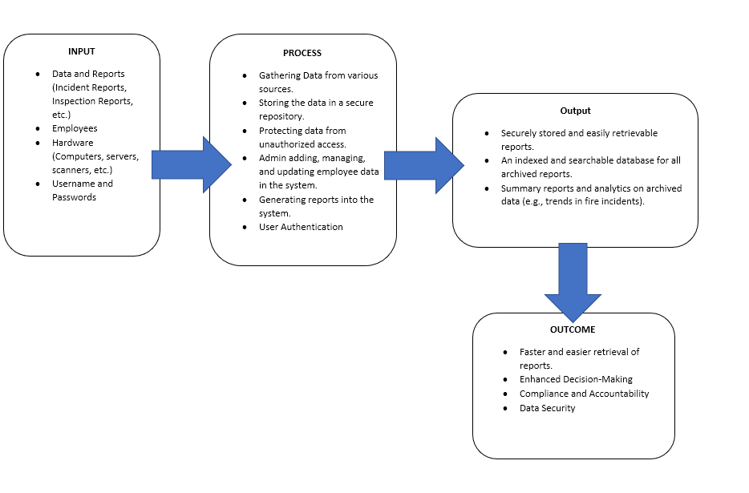

Figure 1. Conceptual Framework of Report Archiving System

REVIEW OF RELATED LITERATURE

Effective data management is vital in ensuring accuracy, accessibility, and security of organizational information. Data management involves implementing policies and procedures that allow institutions to control their data throughout its life cycle. This minimizes the risks of non-compliance, data loss, and security breaches, while ensuring the availability of accurate and timely information for decision-making. The emergence of digital technologies has transformed how organizations handle data, leading to the development of systems that automate archiving, storage, and retrieval processes.

Archives

Modern organizations emphasize efficiency and cost-effectiveness in document management. Office operations require saving and retrieving information in an organized manner to support administrative and operational needs (Hameed et al., 2015). Traditionally, documents were written or printed on paper to serve as legal evidence or references for future use. However, as technology advanced, documents evolved into digital formats created using applications or word processors, stored in various digital media, and easily retrieved when needed (Al-Azawi, 2012).
Small to large companies manage multiple forms and documents daily; these records serve as the foundation for business decisions and operational improvements (Jayoma et al., 2020). Estrera (2017) emphasized that documents play a crucial role in institutions as evidence of transactions and operations that must be managed systematically. Similarly, Johansen and Caluza (2017) developed an electronic document archive management system for a university registrar, which significantly improved the efficiency and reliability of document storage. These studies highlight how effective record management ensures operational continuity and accountability in organizations.
With the growing volume of paper-based records, institutions have begun exploring digital archiving as a solution to enhance data accessibility, reduce physical storage needs, and strengthen record preservation.

Digital Archiving

Over the past century, archiving has evolved from traditional recordkeeping to technology-driven processes. Goudarouli (2023) explained that the archival landscape is undergoing a transformation due to the integration of digital technologies and artificial intelligence, requiring archivists to develop new competencies for managing digital records. In the 21st century, digital archiving has become an essential component of institutional recordkeeping, academic publishing, and government data management.
According to Mukred and Yusof (2015), electronic records management supports informed decision-making and ensures the long-term preservation of important institutional documents. Patwardhan and Lawson (2016) noted that accessibility and structured data storage are crucial in enabling data reuse and integration. Likewise, Musser (2016) emphasized the importance of digital preservation systems in maintaining scientific and technical records for future reference.
Recent advancements have also highlighted the role of cloud-based solutions in archiving. Ahmed and Rahman (2021) argued that cloud-based digital archives improve scalability and accessibility, allowing real-time collaboration and efficient backup management. However, they also cautioned that such systems must integrate strong security features, such as encryption and multi-factor authentication, to prevent unauthorized access to sensitive data.
While digital archiving offers convenience and efficiency, data protection remains a major concern. Lopez and Santos (2020) found that government institutions often face challenges in maintaining data integrity due to weak authentication mechanisms. Their study recommended adopting layered security frameworks—such as role-based access control and regular system audits—to strengthen confidentiality and reduce data loss.
Together, these studies demonstrate that while digital archiving significantly enhances document management, the design of secure, reliable, and user-friendly systems remains a key challenge, especially in the context of government agencies handling confidential information.

Archiving Systems

An archiving system is designed to organize, store, and preserve valuable records for long-term access and institutional use. Fitriyani et al. (2022) stated that manual archiving systems are prone to document loss and damage caused by human error or disasters, underscoring the need for electronic systems. Kassab et al. (2017) similarly identified that manual systems suffer from inefficiency, inaccuracy, and limited transparency, recommending the development of digital systems to improve data flow and prevent file destruction.
Patterson (2016) stated that Archivists have been investigating the perceptions of the public about archives using different methods that include writing down anecdotes and most commonly examining representations of archives and archivists in writing, television, and motion pictures. Archivists also devoted a lot of time to researching the evolution of digital technologies, the Internet, the consequences of the public’s information-seeking behaviors.
Zahara and Salim (2022) emphasized that preservation is the most strategic component of archiving, as it ensures that digital materials remain authentic, reliable, and usable over time. Rosa et al. (2017) added that the rapid growth of digital data makes traditional archiving methods insufficient for long-term preservation. Bacciu et al. (2022) also discussed the increasing need for innovative and integrated information management frameworks that are adaptable to modern challenges.
In addition, Mendoza et al. (2023) highlighted that user-centered design principles contribute significantly to the success of archiving systems. Their findings show that systems developed based on user needs enhance usability, reduce retrieval time, and improve user satisfaction. For government offices such as the Bureau of Fire Protection, user-friendly design ensures that employees with varying technical backgrounds can efficiently perform digital archiving tasks.
Chandra and Lee (2022) explored the integration of Artificial Intelligence (AI) in archival management. They found that AI technologies—such as Optical Character Recognition (OCR) and Natural Language Processing (NLP)—can automate document classification, detect duplicate files, and improve metadata tagging. These technologies enhance accuracy, reduce manual effort, and support predictive data management in institutional archives.
Millar (2017) asserted that an effective archival environment requires formalized information management processes to ensure that records are securely preserved and easily retrievable. Caluza (2022) likewise found that transitioning from manual to computerized systems greatly enhances data security, retrieval efficiency, and monitoring accuracy. These findings reinforce the importance of implementing digital systems that streamline data management, ensure long-term preservation, and improve organizational workflow.

Synthesis and Research Gap

In summary, previous studies emphasize the importance of efficient, secure, and accessible archiving systems across different institutions. While existing research provides valuable insights into electronic document management, most focus on corporate, academic, or scientific settings rather than government emergency service agencies. There remains a gap in developing specialized archiving systems tailored for the Bureau of Fire Protection (BFP) and similar agencies that handle confidential, operational, and time-sensitive reports. Moreover, little attention has been given to offline and locally secured systems suitable for areas with limited internet connectivity—conditions common in local government offices such as BFP Matalam.
Therefore, this study aims to address these gaps by designing and developing a Report Archiving System that provides a secure, offline, and user-friendly platform for managing, retrieving, and preserving BFP reports, thereby improving operational efficiency and data integrity.

METHODOLOGY

This chapter details the research design, data collection, and analysis procedures used in the research.

Research Design

The project used the Descriptive Method to determine the usefulness and functionality of the system.

Research Participants and Materials

The respondents of the project are the personnel of BFP Matalam. Seventeen (17) BFP personnel took part in the study. They were asked to use the system and provide feedback on its functionality.

Data Collection

The researcher will present a letter of permission to the mayor’s office of Matalam. The researcher used survey questionnaires to collect data from the BFP personnel. Personal information from the respondents is protected and private to ensure anonymity.

Data Analysis

The result of the survey was summarized by using descriptive tools in frequency counts. The result of the evaluation was measured using the four-point scale. The verbal descriptions were derived from specific value ranges, as presented in Table 1.

Table 1. Likert Scale
SCALE | MEAN RATING | VALUE
1  2  3  4 | Strongly Disagree  Disagree  Agree  Strongly Agree | 1.00-1.49  1.50-2.49  2.50-3.49  3.50-4.00

Validity

In this study, the collected data will be presented. The researcher will use the following methodologies:
- The researcher will choose the most suitable and competent participants for the study to guarantee that the gathered data is accurate, correct, and reliable. After the data collection, the researcher is responsible for safeguarding the information provided by the respondents.
- To avoid the misuse of other researchers, emphasis will be placed on maintaining consistency throughout the data collection process. Prioritizing objectivity and presenting only accurate information to prevent personal biases and changes.
- The results of the research will be presented in narrative form to help readers understand them.
- Transparent information regarding the location, content, and methods of data gathering will support the data’s transferability, thereby establishing its validity.

Ethical Consideration

The researcher prioritizes the privacy of the respondents. The questionnaire will be distributed to the participants. Before conducting the study, the researcher will seek permission from the organization’s head office. The gathered data will be used for academic purposes only and will be kept confidential; anonymity will be ensured to the respondents to consider ethical confidentiality. The researcher will then ensure that all the data and information of the entire organization will be kept private.

Project Development

Prototype Model

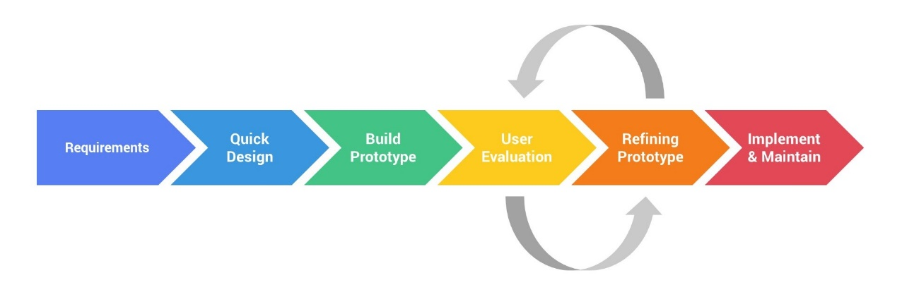
The project will be using the prototype model in managing the system development process. The prototype model is a system development approach where an initial version of the system or prototype is created and refined based on user feedback. In this process, the researcher builds a simplified version of the system to allow users to interact with it early on. This will allow users to provide feedback on the functionality, usability, and design, helping to identify potential issues and refine requirements. The prototype of the system would involve testing data organization, search functionalities, and access controls to ensure they align with user expectations.
Figure 2. Prototype Model Development of Report Archiving System.

Requirements – The creation of a prototype model begins with requirement analysis. The system's requirements are defined in depth during this phase. During the process, system users are interviewed to determine what they expect from the system.
Quick Design – At this stage, a simple design of an archiving system for BFP Matalam is being developed. It is, however, not a complete design. It provides the user with a high-level overview of the system. The quick design helps in the development of the prototype.
Build Prototype – In this phase, a prototype is designed based on the gathered information from the quick design. It is a small working model of the required system.
Initial User Evaluation – In this stage, the proposed system is shown to the users for an initial evaluation. It helps to determine the working model’s strengths and weaknesses. Customer suggestions and comments are collected and provided to the developer.
Refining Prototype – If the users are dissatisfied with the present prototype, you must refine it based on their feedback and suggestions. This phase will not be completed until the users' criteria are met.
Implement and Maintain – The final system is thoroughly tested and deployed to production when it is developed based on the final prototype. Routine maintenance is performed on the system to save downtime and prevent large-scale failures.

Gantt Chart

Figure 3 shows the Gantt chart for the Report Archiving System. This visualizes the various steps that would take place during the planning and implementation of the proposed system. This will help the proponent plan, arrange, and track the process of the project. Bars are used to represent the errands as well as the timeline with the beginning and end dates.
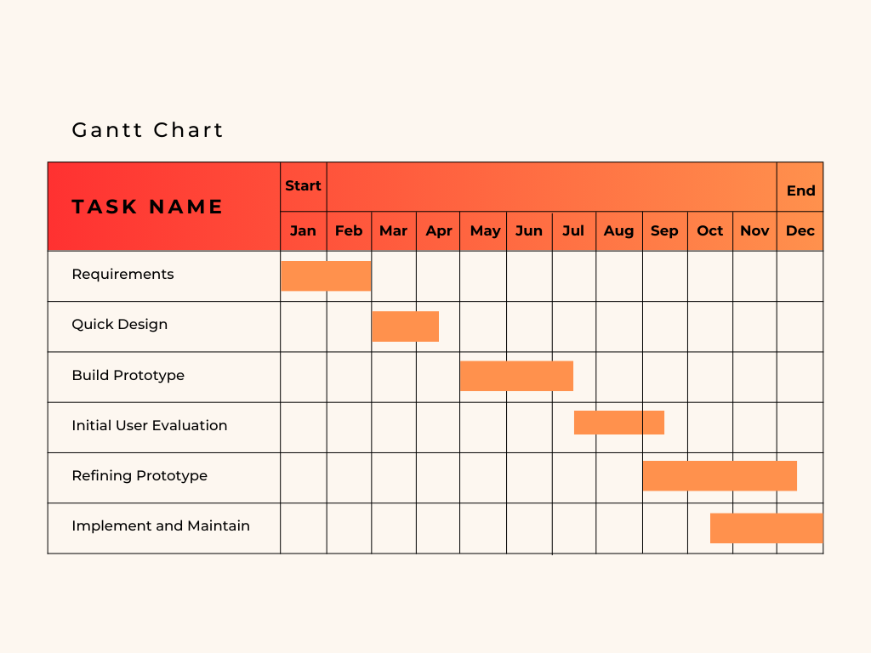

Figure 3. Gantt chart of the Report Archiving System

Functional Requirements

- User Signup
Input: User details
Process: Create a user account in the system’s database.
Output: The user will be added to the database of the system.
- User login to the system
Input: Username and Password
Process: The system will validate the user input, and the login will be done if valid. Otherwise, the user will be asked to re-enter the username and password.
Output: The homepage will be displayed.
- Create Reports
Input: Report details (e.g., type of incidents, place, time, casualties, etc.)
Process: Upload reports to the system’s database.
Output: A confirmation message indicating the successful addition of new reports.
- Searching Reports
Input: The user will search the report name, category, type, etc.
Process: The system will confirm the report’s existence.
Output: Display searched reports.

- Adding User
Input: User Details
Process: Enter user details and verify.
Output: The user will be added to the database of the system.
- Managing User Profiles
Input: Admin access user profiles.
Process: Admin will select, edit, or update the user information in the system.
Output: A confirmation message indicating the successful update of user profiles.
- Editing Reports
Input: User accesses the archives.
Process: User will select and edit the report’s metadata and save the updated reports into the system’s database.
Output: Confirmation message indicating the successful update of the report.
- Retrieving Reports
Input: The user opens the archive page.
Process: Search the report and click download.
Output: Report downloaded.

- Delete Report
Input: The user selects the report.
Process: Remove the report.
Output: A confirmation message indicating the successful deletion of
the report.
- Generate Reports
Input: System retrieves relevant data from the database.
Process: System performs calculations, applies filters, sorts the data,
and organize the data into a user-friendly format, such as charts and
graphs.
Output: Generated reports displaying summarized and visualized data (e.g., charts, tables, and graphs) that provide insights for decision-making and record-keeping.
- User logout to the system
Input: The user will click the logout button.
Process: The system will ask the user to confirm the logout. If yes, terminate the user's access to the system, and if no, return to the homepage.
Output: The system’s login page.

Hardware and Software Specification

Table 2 shows the software requirements that are needed for the development of the system. It also describes the functionality of the system to fulfill the administrator’s and users’ needs.

Table 2. Software Specification

SPECIFICATION | MINIMUM | RECOMMENDED
Operating System  System Type  Database  Software Application  Programming Language | Windows 7  32-bit OS  MySQL Server 2014  Visual Studio 2015  CSS/JavaScript/PHP | Windows 10/11  64-bit OS  MySQL Server 2014  Visual Studio 2015  CSS/JavaScript/PHP

Table 3 shows the hardware requirements that can be used to support the smooth flow of the system process.
Table 3. Hardware Specification

SPECIFICATION | MINIMUM | RECOMMENDED
Processor  Hard Disk  Memory  Connectivity | Intel Celeron  250 GB  2 GB RAM  Internet | Intel Core i5  500 GB  8 GB RAM  Internet

Entity Relationship Diagram

The Entity Relationship Diagram for the development of an archiving system outlines the key components and their interconnections. The ‘Admin’ and ‘Employee’ entities represent the users, with the admin managing multiple employees (one-to-many relationship). It represents a hierarchical structure where one admin oversees all employees, enabling administrative tasks such as user management. Reports are created by either an admin or employee, linking back to them through the CreatorID. This relationship records who is responsible for generating each report. The ‘Category’ and ‘Report’ entities are connected through a many-to-many relationship (M:M), facilitated by the ReportCategory junction table. This relationship allows each report to be associated with multiple categories and vice versa. ‘Tags’ are managed independently but are associated with ‘Reports’ via ‘ReportTag’ table, enabling multiple tags per report and vice versa. Lastly, the ‘AccessLog’ entity tracks which user (neither ‘Employee’ nor ‘Admin’) accessed which reports and when. This relationship will help in auditing and monitoring system usage.
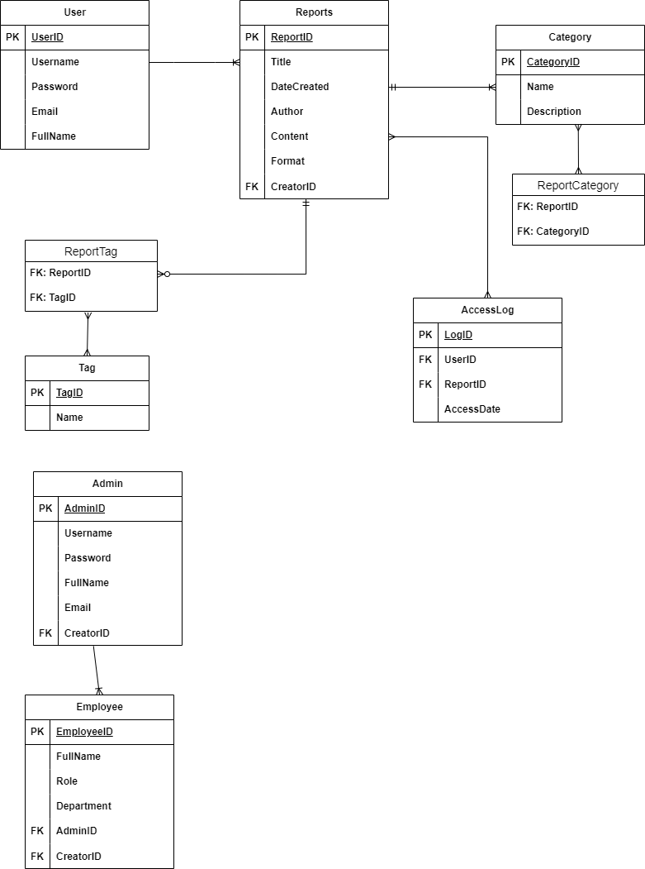

Figure 3. Entity Relationship Diagram for the Development of Report
Archiving System.
Use Case Diagram

Figure 4 shows a graphical representation of the system's functionality in terms of user and system capability. It demonstrates how users interact with the system. The admin is capable of managing the overall aspect of the system, such as adding employees, accessing and managing user profiles, accessing user activity, and restoring deleted reports. While the Employee can only retrieve, search, delete, update, and create reports, and is restricted from accessing other user profiles.

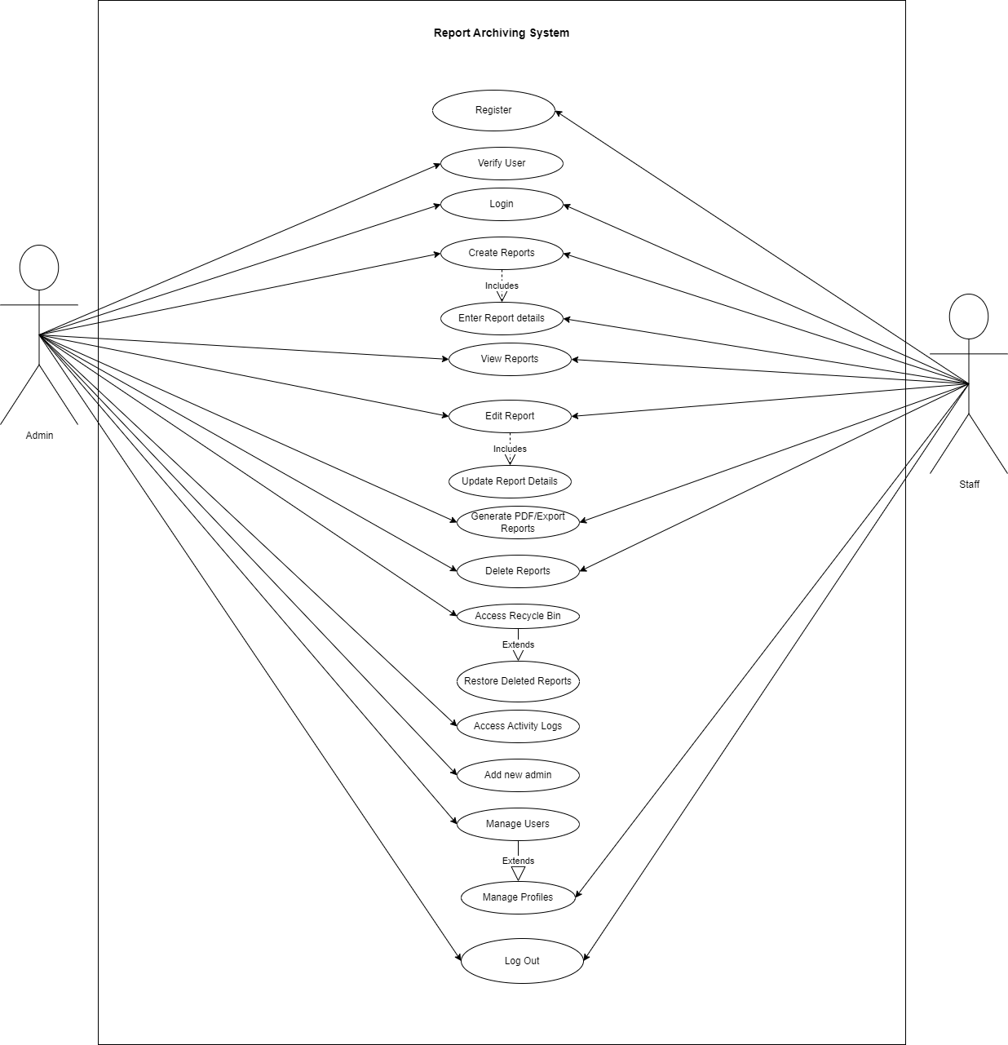
Figure 4. Use Case Diagram for the Development of Report Archiving
Class Diagram

Figure 5 illustrates the system classes and their relationships. In the class diagram the “User” class has one-to-many relationship with the “Report” class, indicated by a solid line connecting them with “1” near “User” and “N” near report. This means that a single user can manage multiple reports, but each report is associated with one user. The “Report” class has an aggregation relationship with the “Archive” class, represented by a solid line with a diamond at the “Archive” end. The cardinalities here are “N” near “Report” and “1” near “Archive”, indicating that multiple reports can be archived and each archived entry is related to a specific report. Additionally, the “Admin” class inherits from the “User” class, shown by a solid line with a hollow triangle pointing from “Admin” to “User”, signifying that an admin is a specialized type of user with additional privileges.
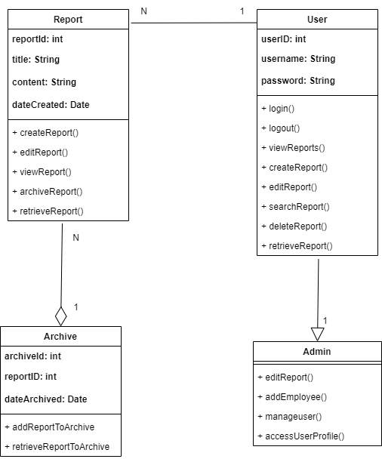

Figure 5. Class Diagram for the Development of Report Archiving System

Activity Diagram

Login Activity Diagram

Figure 6, This activity diagram shows the login process to the system. The admin and the user are required to enter their username and password to access the system. The system will validate if the username and password are correct. If valid, the user will be directed to the system’s homepage.
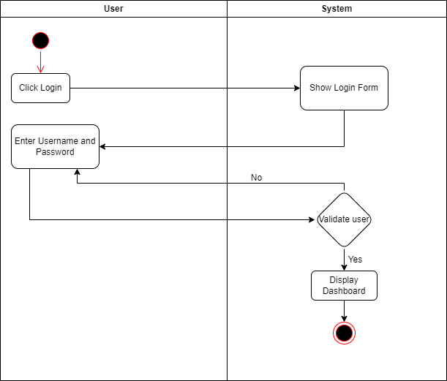

Figure 6. Login Activity Diagram

Signup Activity Diagram

Figure 7 shows the signup process of the system. The user is required to enter the necessary details to get access to the system. Then, the system will validate if the entered details are complete and correct. If valid, the user will be directed to the login page of the system.
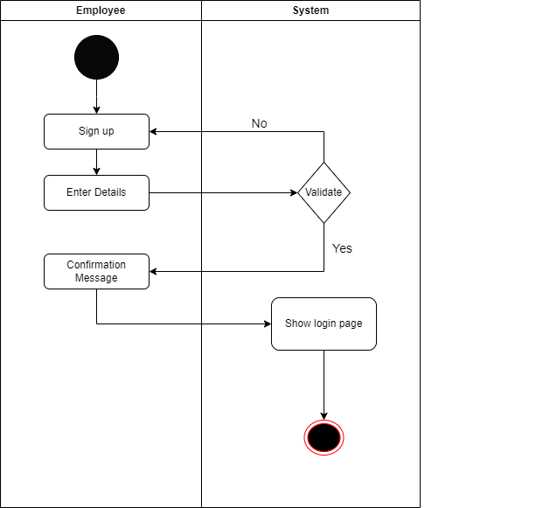

Figure 7. Signup Activity Diagram
Add New User Activity Diagram

Figure 8 shows the steps of an admin adding a new admin to the system. In this diagram, the admin adds new admins and sets permissions to users based on their role and responsibilities.
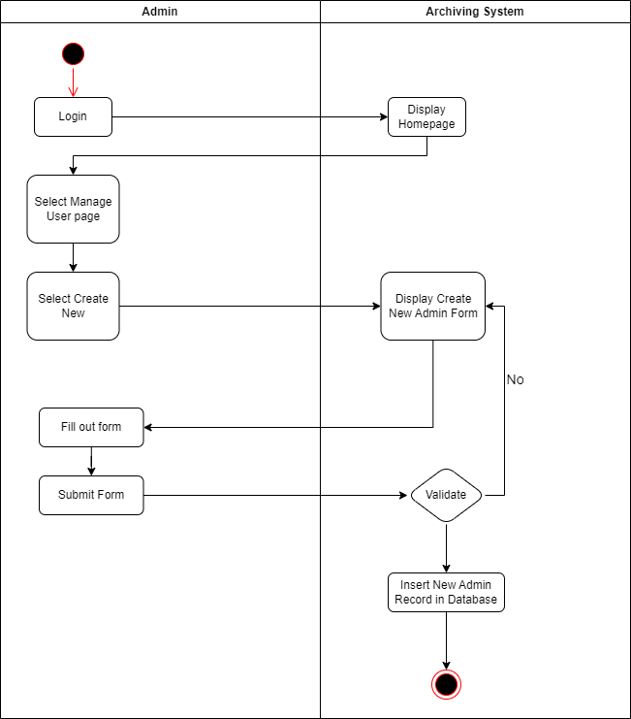

Figure 8. Add New User Diagram

Delete Report Activity Diagram

Figure 10 shows the process of deleting reports from the system. The user can delete reports; the system will show a message box to the user. If yes, a message will pop up confirming the deletion of the report.
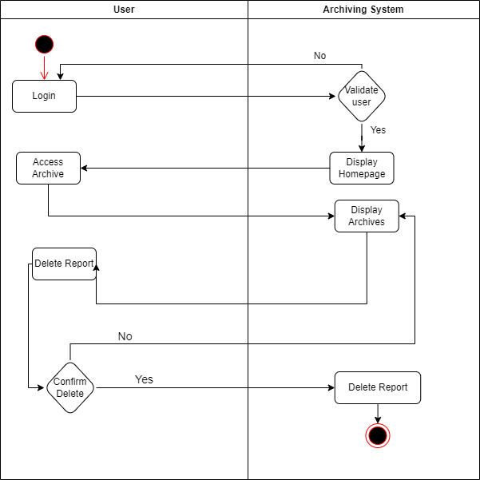

Figure 10. Delete Activity Diagram

Downloading Reports Activity Diagram

Figure 11 shows the process of downloading reports from the system. In this diagram, the user will search for reports and the system will confirm the report’s existence. Then, the user can download or retrieve reports from the system’s archives.
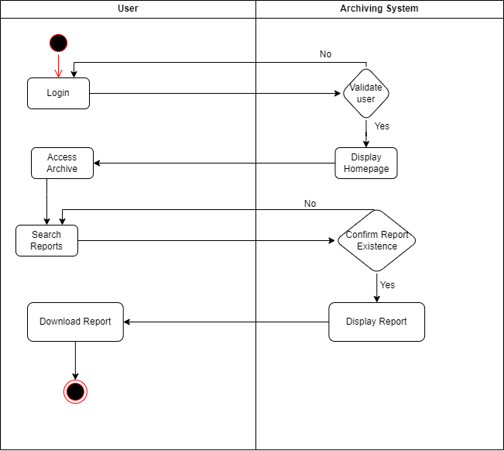

Figure 11. Reports Retrieval Activity Diagram

Manage User Activity Diagram

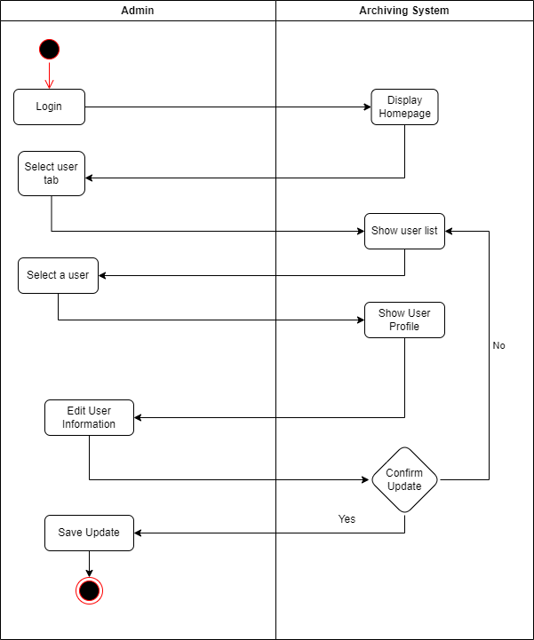
Figure 12 shows the process of managing user profiles by an admin. In case of mistakes, the admin can select, edit, and update the user information in the system. The system will show a message confirming the information update. If yes, the admin can save the updated profile to the system.

Figure 12. Manage User Activity Diagram
Create Report Activity Diagram

Figure 13 shows the activity diagram that illustrates the flow of activities involved in generating reports in the Report Archiving System. It showcases the steps of creating reports through the report form, entering report details, and reviewing the reports.
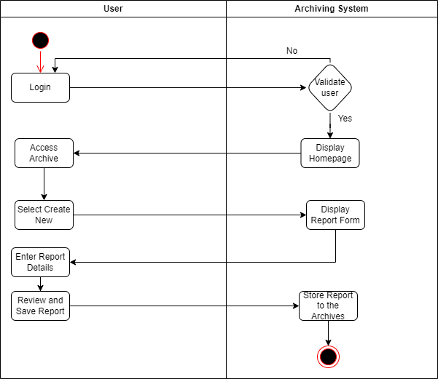

Figure 13. Create Report Activity Diagram

Edit Reports Activity Diagram

Figure 14 illustrates the activity diagram of the flow of activities involved in editing reports in the Report Archiving System. The user can select, view, and update the report’s metadata. The updated report will be saved and stored in the system’s database. A message will be displayed confirming the successful update of the report.
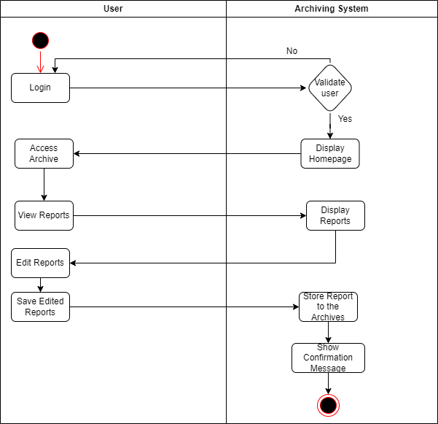

Figure 14. Edit Activity Diagram

Searching Reports Activity Diagram

Figure 15 shows the process and steps involved in searching for documents. The user can search the archives in order to view and retrieve reports.
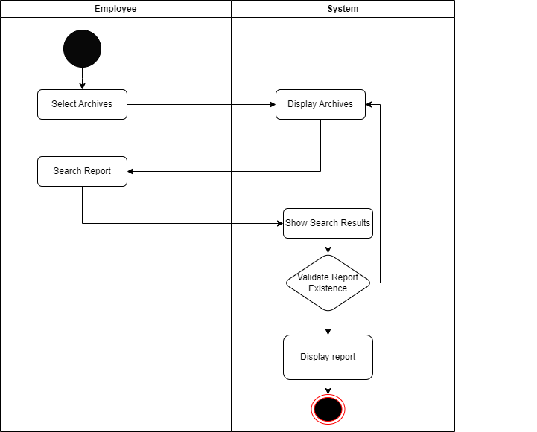

Figure 15. Searching Reports Activity Diagram

Generating Reports Activity Diagram

Figure 16, shows the process of generating reports in an archiving system. The system will collect the relevant data from the database and perform calculations, apply a filter, and organize the data into a user-friendly format such as charts and graphs. The user can view and print the generated reports.
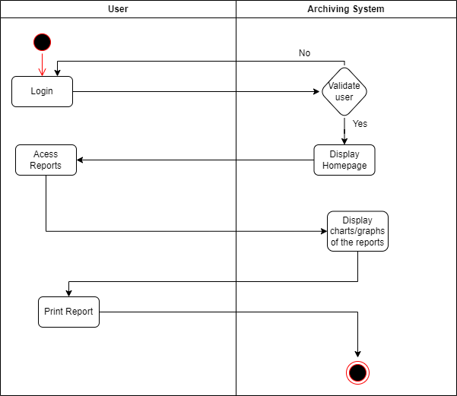

Figure 16. Generate Reports Activity Diagram

RESULTS AND DISCUSSION

The Bureau of Fire Protection Report Archiving System was successfully developed to address the operational inefficiencies associated with manual document storage and management. The system was evaluated by seventeen (17) BFP personnel, including administrative staff and field officers, who assessed its functionality, usability, and effectiveness in addressing the identified problems. The findings reveal significant improvements in document management practices and demonstrate the system's potential to enhance operational efficiency at BFP Matalam.

Design and System Development

The researcher successfully designed and developed the Report Archiving System for the Bureau of Fire Protection Matalam, addressing the general objectives of managing and storing reports virtually. The system was developed as an offline application to ensure functionality without the need for an internet connection. The system was designed to allow administrators and users to securely log in and out, manage report information, and access comprehensive fire incident reports. Admins and users can search for existing reports, add new reports, update report data, and create reports for administrative use. By operating offline, the system enhanced data security and ensured accessibility in areas with limited or no connectivity. It featured an intuitive interface for updating reports, tracking fire patterns, and managing report data, significantly improving administrative efficiency.

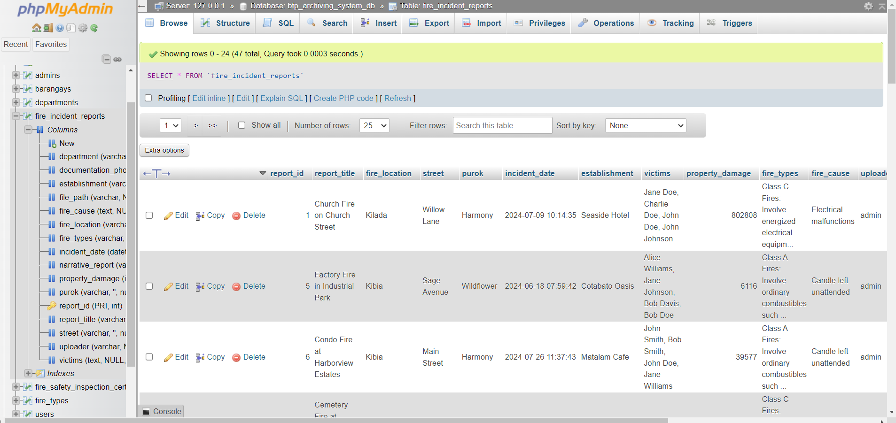

Figure 16. Sample Database of the System.
Development of the BFP Report Archiving System

The Report Archiving System for BFP Matalam was designed to make managing fire protection records simple and efficient. With its clean, user-friendly interface built using PHP, JavaScript, and CSS, the system is easy to navigate, even for those who aren’t tech-savvy. It streamlines the process of organizing and retrieving fire incident reports, inspection records, compliance certificates, and other essential documents. On the back-end, a custom data storage setup ensures that all records are handled securely and processed quickly. This practical and robust solution helps the Bureau of Fire Protection keep its operations organized, scalable, and ready for future needs.
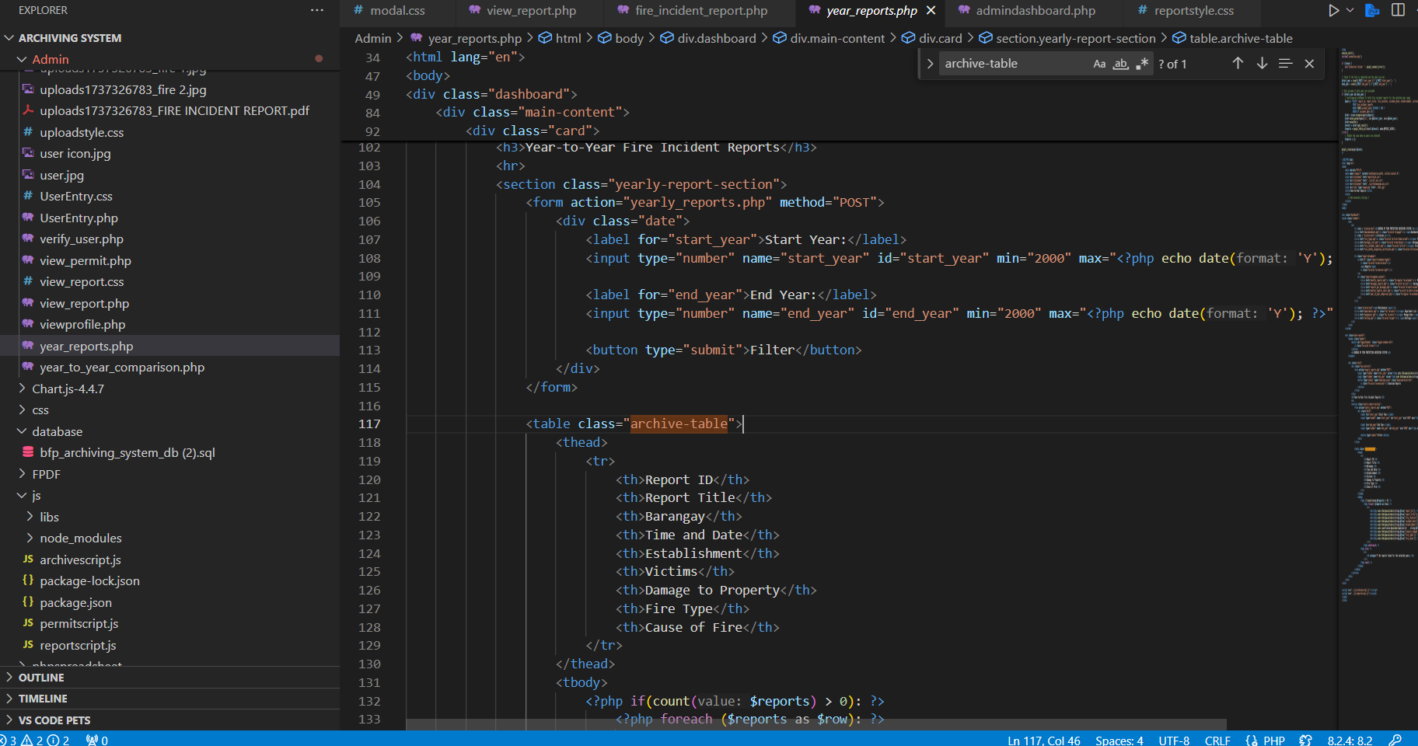

Figure 17. Sample Code
Ensure the System Meets Functionality Requirements Through Regular Evaluations
To ensure that the Bureau of Fire Protection Report Archiving System met all its functional requirements, regular evaluations were conducted throughout its development. These reviews focused on testing key features like user to ensure they worked efficiently and reliably. Each feature was thoroughly tested to confirm it was user-friendly, accessible, and performed as intended. Feedback from these evaluations was invaluable in identifying and resolving technical issues, helping the development team deliver a smooth and reliable experience for users.
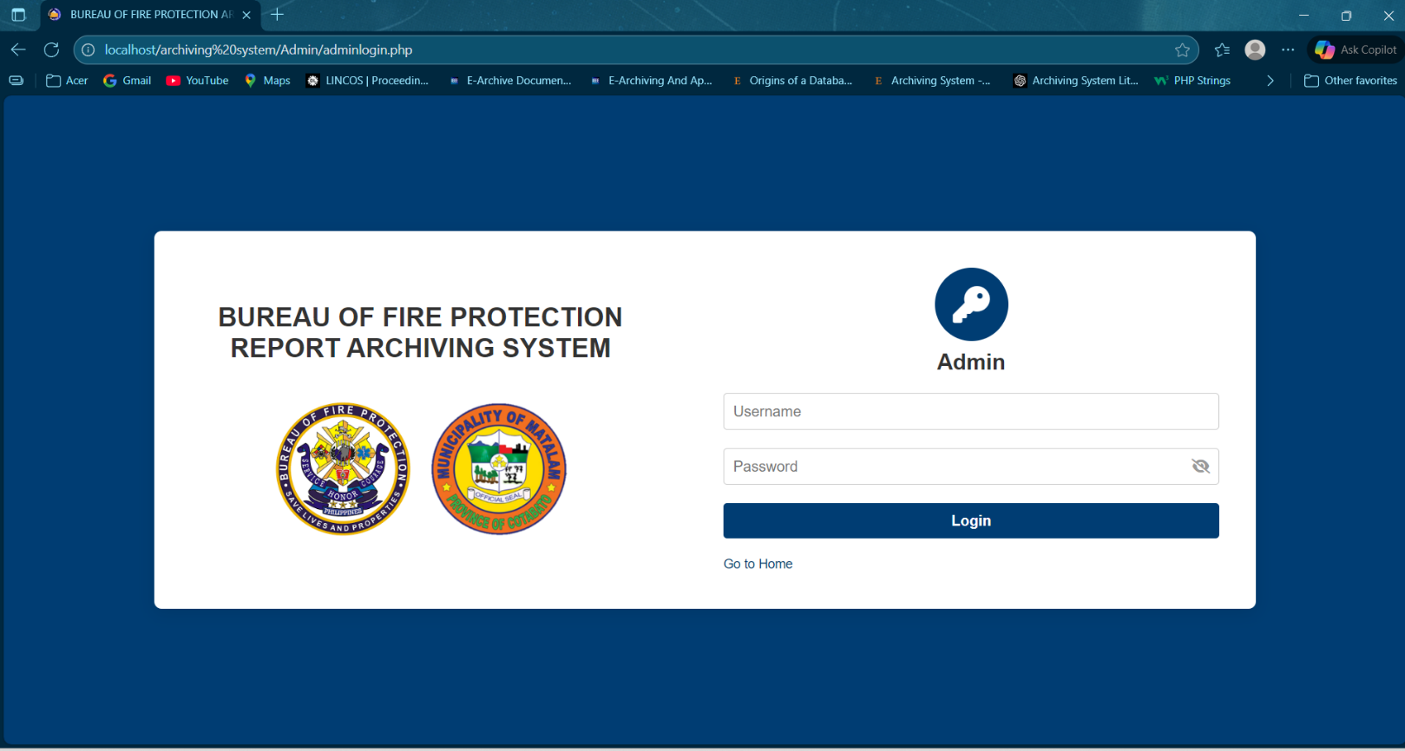

Figure 18. Login Page
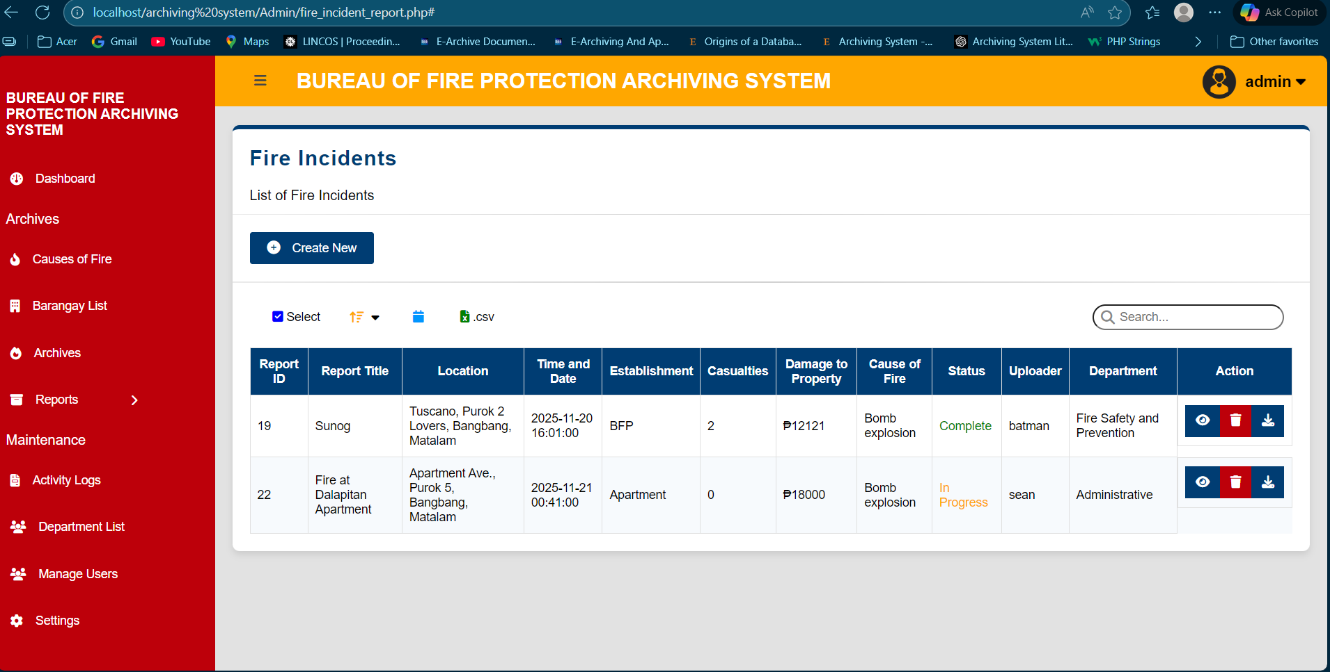
The Bureau of Fire Protection Report Archiving System includes advanced data validation features to ensure the accuracy and reliability of stored records. These features include mandatory field checks to prevent critical fields, such as report details, incident dates, and file references, from being left blank. The system also enforces format validation, ensuring that inputs like dates and report IDs follow the correct structure.

Figure 19. Fire Incident Reports

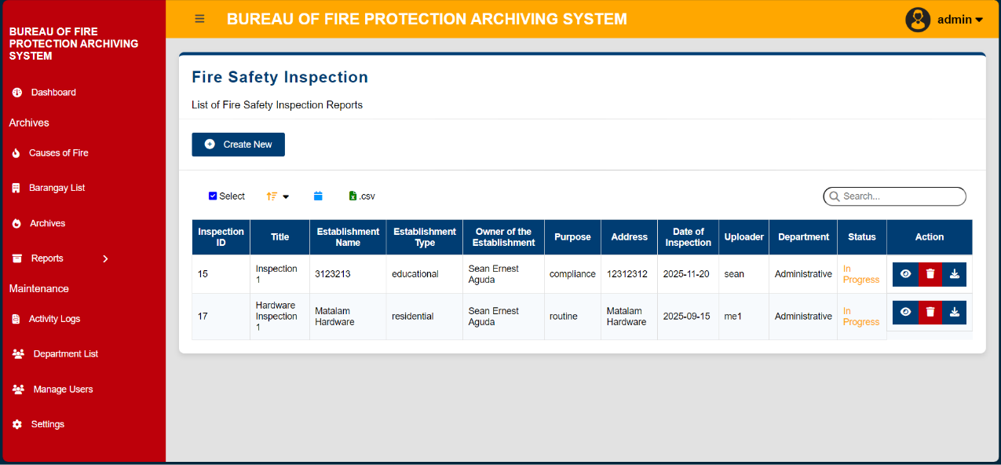

Figure 20. Fire Safety Inspection Reports

User Validation Features: Preventing Unauthorized Entry and Access to Data

The Bureau of Fire Protection Report Archiving System includes a robust user authentication feature to ensure the security and confidentiality of sensitive data. Each user is required to log in with a unique username and password, which grants access based on their assigned role. This role-based access control ensures that only authorized personnel can view, modify, or manage reports. The system also supports session management to prevent unauthorized access, automatically logging users out after periods of inactivity. These security measures protect sensitive information and help maintain accountability in managing fire protection reports.
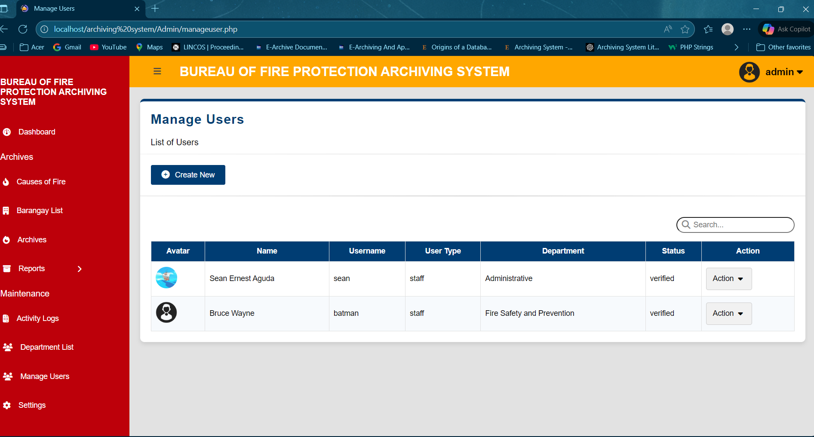

Figure 21. User List

Evaluation Reports Highlighting User Satisfaction with the System’s
Interface and Efficiency

The researcher successfully achieved the fourth objective of the project by evaluating the functionality of the developed system to ensure it performed as intended. User evaluations were conducted with administrative staff, who provided feedback on the system’s design, navigation, and overall functionality. The feedback highlighted the system's user-friendly interface and the speed with which reports and records could be retrieved. The evaluation confirmed that the system met user expectations, making the process of managing fire reports and documents more efficient and streamlined.

Table 4 shows the evaluation results of the system's functionality for the admin, with a weighted average of 3.25, which signifies that the respondents agreed that the system is functional and allowed users to access the system, view, manage, create, and generate reports.

Table 4. Functionality Evaluation Results by admin. Bureau of Fire Protection Matalam. November 2025.
Statement | Weighted Mean | Remarks
Functionality
- The archiving system is easy to navigate and use. | 3.35 | Agree
- I can quickly find the reports I need. | 3.00 | Agree
- Archiving reports is very simple and direct. | 3.18 | Agree
- The search functionality meets my needs. | 3.12 | Agree
- The system provides adequate security for sensitive documents. | 3.29 | Agree
- Generating and exporting reports is efficient and reliable. | 3.18 | Agree
- The system helps reduce paperwork and manual record-keeping. | 3.31 | Agree
- I am satisfied with the speed and performance of the system. | 3.29 | Agree
9. It is easy to manage and track user activity in the system. | 3.25 | Agree
10. Overall, I am satisfied with the archiving system. | 3.53 | Strongly Agree
Total Average | 3.25 | Agree

Legend | Scale | Description | Weighted Mean
 | 1 | Strongly Disagree | 1.00 – 1.49
 | 2 | Disagree | 1.50 – 2.49
 | 3 | Agree | 2.50 – 3.49
 | 4 | Strongly Agree | 3.50 – 4.00

Table 5. shows the staff evaluation results, with a weighted average of 3.50, which signifies that the respondents strongly agreed that the system was functional and allowed users to register, log in, and out of the system, create, search, and download reports in the system.

Table 5. Functionality Evaluation Results by user. Bureau of Fire Protection Matalam. November 2025.
Statement | Weighted Mean | Remarks
Functionality
- The archiving system is easy to use. | 3.41 | Agree
- I can easily upload and access my reports. | 3.25 | Agree
- The search feature helped me find reports quickly. | 3.50 | Agree
- The search functionality meets my needs. | 3.50 | Agree
- The system keeps my files secure and private. | 3.50 | Agree
- The system’s performance meets my expectations. | 3.50 | Agree
- I am satisfied with the appearance and layout of the system. | 3.50 | Agree
- I can easily update or edit reports | 3.50 | Agree
- I can easily update or edit my profile | 3.50 | Agree
- Overall, I am satisfied with the archiving system. | 4.00 | Strongly Agree
Total Average | 3.50 | Strongly Agree

Table 6 shows the overall result for the evaluation of the system’s functionality, evaluated by the admin and user, with an overall average of 3.375, which signifies that the respondents agreed that the system was functional as stated above, and it helps the Bureau of Fire Protection in archiving reports.

Table 6. Overall Functionality Evaluation Results by admin and user. Bureau of Fire Protection Matalam. November 2025.

No | Statement | Weighted Mean | Remarks
1 | Overall result for system functionality evaluation by admin. | 3.25 | Agree
2 | Overall result for system functionality evaluation by the user. | 3.50 | Strongly Agree
 | Average | 3.375 | Agree
SUMMARY, CONCLUSIONS, AND RECOMMENDATIONS

This capstone project aimed to develop a Report Archiving System for the Bureau of Fire Protection (BFP) Matalam to address operational inefficiencies arising from manual document storage and management. The system was designed to automate the storage, indexing, and retrieval of fire-related reports while maintaining secure access control. Specifically, the project pursued three primary objectives: (1) develop an archiving system to manage and retrieve reports; (2) guide BFP personnel to categorize and organize reports virtually; and (3) evaluate the system's functionality.
The project involved seventeen (17) BFP personnel—including administrative staff and field officers—who tested the system and provided comprehensive feedback. The system was successfully developed as an offline application using PHP, JavaScript, CSS, and MySQL, ensuring functionality in areas with limited internet connectivity. Evaluation results demonstrated strong user acceptance, with administrators achieving a weighted mean score of 3.25 ("Agree") and staff members achieving 3.50 ("Strongly Agree"), yielding an overall average of 3.375. These results indicate that the system effectively met user expectations and successfully addressed the identified document management challenges.
The Report Archiving System successfully achieved all three stated objectives. First, the system provides a functional archiving platform that enables efficient storage and retrieval of fire incident reports, inspection records, and other critical documents. Second, it guides BFP personnel through intuitive navigation and organized categorization features, allowing users with varying technical backgrounds to manage reports effectively. Third, comprehensive evaluations confirmed the system's functionality, with all tested features—including user authentication, report creation, search capabilities, and access controls—performing as intended. The system demonstrates significant potential to improve BFP Matalam's operational efficiency. Users reported that the archiving system is easy to navigate (3.35 weighted mean), that they can quickly find needed reports (3.00), and that archiving reports is simple and direct (3.18). These results indicate the system substantially reduces the time and effort previously required for manual document retrieval. By automating document organization and indexing, the system addresses the original problem of time-consuming searches through large paper archives. The offline-enabled design proves particularly valuable for BFP Matalam's operational context. Rather than requiring internet connectivity, the system operates as a secure, locally managed application, ensuring that document management functions remain available regardless of external network conditions. This design choice reflects practical awareness of the constraints facing local government offices.
The overall satisfaction rating of 3.375 across both administrator and staff evaluations indicates strong user acceptance. Staff members reported particularly high satisfaction with the overall system (4.00 weighted mean—"Strongly Agree"), suggesting the system is ready for implementation. The modular design and database structure provide a solid foundation for future enhancements and expansion as organizational needs evolve.
The following suggestions are made to enhance the Bureau of Fire Protection (BFP) Matalam Report Archiving System:
- Develop a notification functionality that would remind the user of the deadlines of the reports to ensure timely completion and submission of reports.
- Provide training sessions for the BFP personnel to maximize the effectiveness of the system.
- Implement enhanced security features, such as multi-factor authentication, to protect users’ and documents’ sensitive information.

LITERATURE CITED

Ahmed, R., & Rahman, M. (2021). Cloud-based digital archiving for public institutions: Benefits and security challenges. International Journal of Information Management Systems, 19(4), 102–115.

Al-Azawi, M. A. (2012). Constructing an e-archive system and its role in improving document management. In International Conference on Knowledge Management and Resource Sharing. Retrieved from https://scholar.google.com/citations

Bacciu, V., Sirca, C., & Spano, D. (2022). Towards a systemic approach to fire risk management. Environmental Science & Policy, 129, 37-44.

Caluza, B., & Ls Johansen, B. (2017). Development of electronic document archive management system (edams): A case study of a university registrar in the Philippines. International Journal of Digital Information and Wireless Communications (IJDIWC), 7(2), 106-117.

Chandra, P., & Lee, S. (2022). Artificial intelligence applications in digital archiving and record management systems. Journal of Information Systems and Technology Research, 10(1), 45–59.

Estrera, P. J. M. (2017). Electronic Document Management System for Higher Education Institution. International Journal of Innovative Science and Research Technology, 2(5).

Fitriyani, A., Handayani, D., Noeman, A., Mahbub, A. R., Salkiawati, R., & Fathurrozi, A. (2022). E-Archive Document Clustering Information System Using K-Means Algorithm. In Proceedings of the Seventh International Conference on Informatics and Computing (ICIC), Denpasar, Bali, Indonesia (pp. 1-5). IEEE. https://doi.org/10.1109/ICIC56845.2022.10006935

Goudarouli, E. (2023). Digital Innovation and Archival Thinking. Oxford Twenty- First Century Approaches to Literature, 267.

Hameed, K. W., Ahmed, S. A., & Mohammed, A. A. (2015). Web-Based Archiving System. i-Manager's Journal on Information Technology, 4(3), 14.

Jayoma, J. M., Moyon, E. S., & Morales, E. M. O. (2020). OCR- based document archiving and indexing using PyTesseract: A record management system for DSWD Caraga, Philippines. In 2020 IEEE 12th International Conference on Humanoid, Nanotechnology, Information Technology, Communication and Control, Environment, and Management (HNICEM) (pp. 1-6). IEEE.

Kassab, M. K. I., Naser, S. S. A., & Al Shobaki, M. J. (2017). An analytical study of the reality of electronic documents and electronic archiving in the management of electronic documents in the Palestinian pension agency (PPA).

Lopez, M. R., & Santos, J. P. (2020). Enhancing data protection in government digital archives through layered security frameworks. Philippine Journal of Information Science and Technology, 15(2), 56–68.

Mendoza, K. L., Villanueva, J. R., & Cruz, A. M. (2023). User-centered design principles in document management systems. Asian Journal of Computer Studies, 12(3), 210–223.

Millar, L. A. (2017). Archives: Principles and practices. Facet Publishing.

Mukred, M., & Yusof, Z. M. (2015). The role of electronic records management (ERM) for supporting decision-making process in Yemeni higher professional education (HPE): A preliminary review. Jurnal Teknologi, 73(2), 117-122.

Musser, L. (2016). Preserving the digital record of science and engineering: The challenge of new forms of grey literature. Issues in Science and Technology Librarianship, 83.

Patterson, C. (2016). Perceptions and understandings of archives in the digital age. The American Archivist, 79(2), 339-370.

Patwardhan, A., & Lawson, C. L. (2016). Chapter Fifteen - Databases and Archiving for CryoEM. In R. A. Crowther (Ed.), Methods in Enzymology (Vol. 579, pp. 393-412). Academic Press. https://doi.org/10.1016/bs.mie.2016.04.015

Rosa, C. A., Craveiro, O., & Domingues, P. (2017). Open source software for digital preservation repositories: A survey. arXiv preprint arXiv:1707.06336.
Zahara, N. R., & Salim, T. A. (2022). Preservation of digital archives: Systematic literature review. Record and Library Journal, 8(2), 285–2 97. https://doi.org/10.20473/rlj.V8-I2.2022.285-29
Zhang, J. (2018). Digital archival representation: Approaches and challenges. In Organization, Representation and Description through the Digital Age: Information in Libraries, Archives and Museums (pp. 89-102). Berlin: De Gruyter.

APPENDICES

Appendix A. Actual Budget of the Research
College Seal
UNIVERSITY OF SOUTHERN MINDANAO
Kabacan, Cotabato
Philippines
ACTUAL BUDGET OF THE RESEARCH
REPORT ARCHIVING SYSTEM FOR BFP MATALAM
48
ITEMS/DESCRIPTION | ACTUAL COST
- Fare  - Print  - Internet  - Bond paper | 1,500  2,000  2,500  1,000
GRAND TOTAL | 7,000

Prepared and submitted by:

SEAN ERNEST P. AGUDA
Printed Name and Signature of the Student
NOTED
JOSEPH C. LORILLA  Adviser | ___________________________  Date
CATHERIN C. DAFFON  Department Research Coordinator | ___________________________  Date
JANICE T. PALMAERA  Department Chairperson | ___________________________  Date
USM-EDR-F18-Rev.0.2022.10.18
Appendix B. Application for Thesis Manuscript Defense


UNIVERSITY OF SOUTHERN MINDANAO
College Seal
Kabacan, Cotabato
Philippines
APPLICATION FOR THESIS MANUSCRIPT DEFENSE

Name | SEAN ERNEST P. AGUDA
Degree/Major | BACHELOR OF SCIENCE AND INFORMATION SYSTEMS
Thesis Title | REPORT ARCHIVING SYSTEM FOR BFP MATALAM
Date of Examination
Time
Place

MEMBERS OF THE EXAMINING COMMITTEE

Name Signature Date

NOR-AINE M. CORPUZ __________________ __________________
ARJAY S. AGBUNAG __________________ __________________
DANILYN A. FLORES __________________ __________________

RECOMMENDING APPROVAL:

JOSEPH C. LORILLA _______________________________
Adviser Co-Adviser (Optional)
APPROVED:

_______________________________ CATHERINE C. DAFFON
College Statistician Department Research Coordinator
(Optional)
JANICE T. PALMAERA
Department Chairperson

REPORT ON THE RESULT OF EXAMINATION

Name Signature Remarks

NOR-AINE M. CORPUZ __________________ __________________
ARJAY S. AGBUNAG __________________ __________________
DANILYN A. FLORES __________________ __________________

APPROVED:

JANICE T. PALMAERA
Department Research Coordinator

_____________________
Date
USM-EDR-F08-Rev.3.2020.02.24

Appendix C. Sample Answered Questionnaires

Appendix D. Evaluation Photos

The researcher conducted an evaluation of the functionality of the system, and here are some sample photos that were collected.

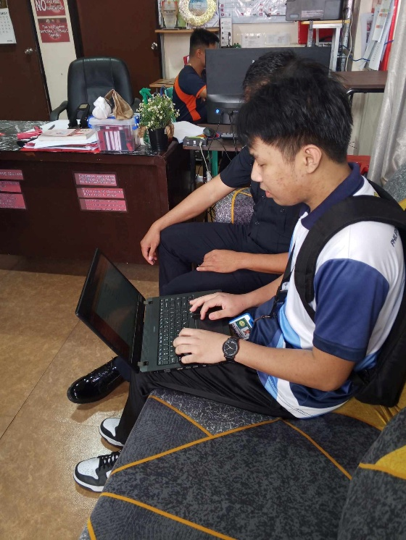
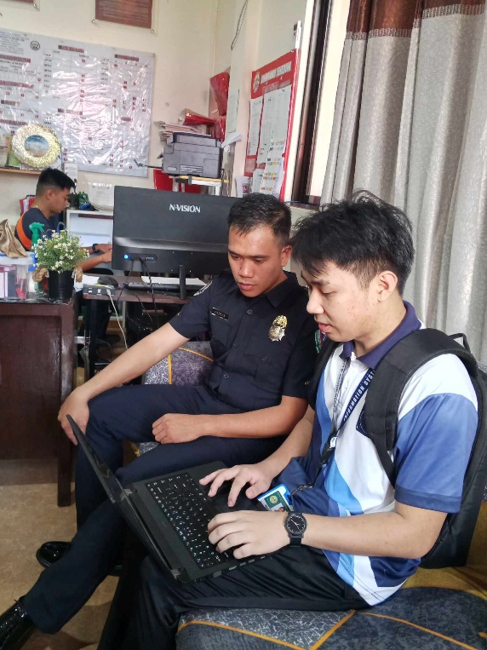
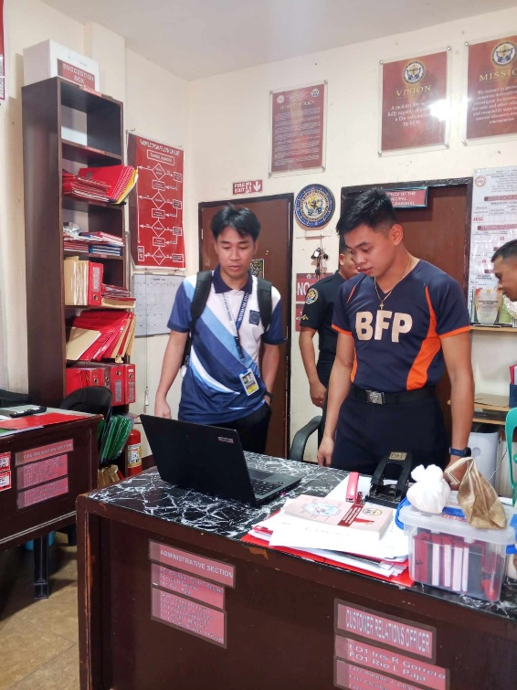
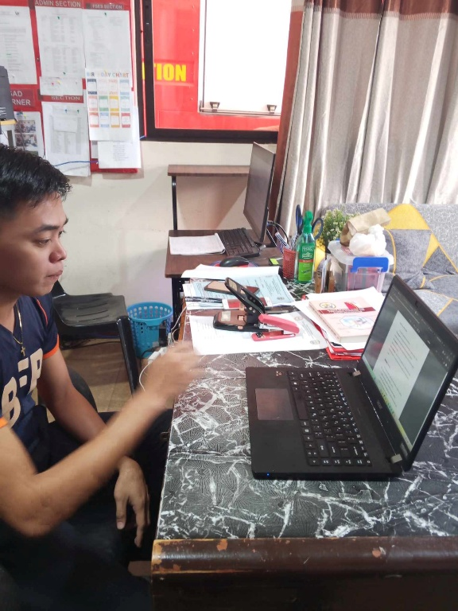

College Seal
UNIVERSITY OF SOUTHERN MINDANAO
Kabacan, Cotabato
Philippines
APPLICATION FOR RESEARCH ADVISER
Appendix E. Certificate of English Critique
Republic of the Philippines
UNIVERSITY OF SOUTHERN MINDANAO
Kabacan, Cotabato

COLLEGE OF ENGINEERING AND INFORMATION TECHNOLOGY

CERTIFICATION OF ENGLISH CRITIC

Name: SEAN ERNEST P. AGUDA

Degree Sought: BACHELOR OF SCIENCE IN INFORMATION SYSTEMS

This is to certify that the thesis project outline entitled: REPORT ARCHIVING SYSTEM FOR BFP MATALAM, conducted by SEAN ERNEST P. AGUDA, was edited by the undersigned.

JOSEPH C. LORILLA
Signature over Printed Name Date

I confirm that this study has been checked by the English Critic.

JOSEPH C. LORILLA
Adviser’s Signature over Printed Name Date

Appendix E. Curriculum Vitae

College Seal
UNIVERSITY OF SOUTHERN MINDANAO
Kabacan, Cotabato
Philippines

CURRICULUM VITAE

SEAN ERNEST P. AGUDA
Poblacion, Matalam, Cotabato
09777461096
seaguda@usm.edu.ph

PERSONAL INFORMATION
Last Name | AGUDA
First Name | SEAN ERNEST
Middle Name | PAMONAG
Nickname | MIGS
Age | 23
Nationality | FILIPINO
Religion | ROMAN CATHOLIC
Civil Status | SINGLE
Father’s Name | ROMMEL M. AGUDA
Mother’s Name | MAY P. AGUDA
Educational Background
Elementary | MATALAM CENTRAL ELEMENTARY SCHOOL
Junior High School | MATALAM HIGH SCHOOL
Senior High School | MATALAM HIGH SCHOOL
Tertiary | UNIVERSITY OF SOUTHERN MINDANAO

